Inventory transfer

Retail One use SAP warehouses

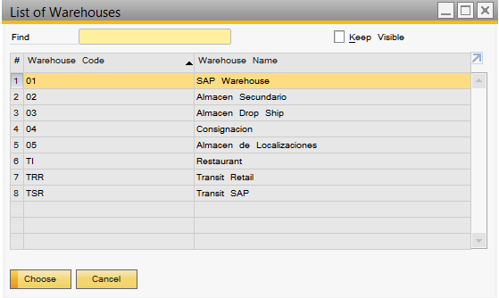

In SAP, we can´t do inventory movements in Retail One warehouses directly, we need configure a transit warehouse.

In configuration screen, tab inventory transfer, we define transit warehouses used by Retail One.

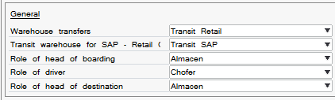

First option is for Transit between Retail One warehouse and Retail One warehouse (store to store).

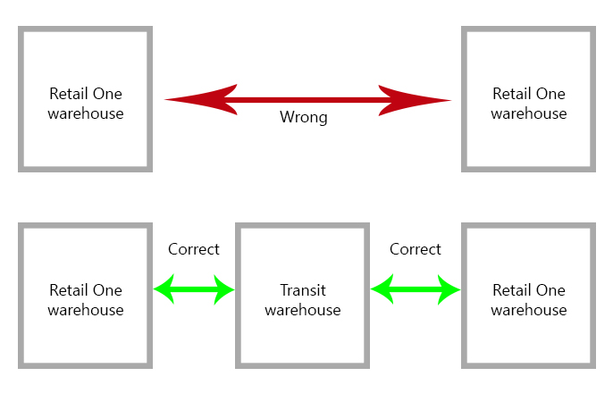

Second option is for transit between SAP warehouse and Retail One.

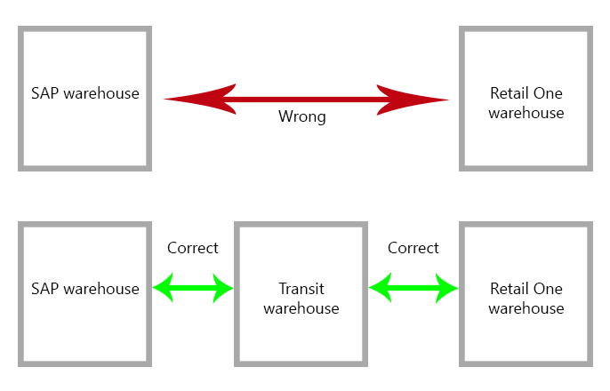

Option 3, 4 and 5 is for select responsible for transfer in Retail One.

Retail One have a module for create a transfer stock to another warehouse



In this screen, we scan items for transfer.

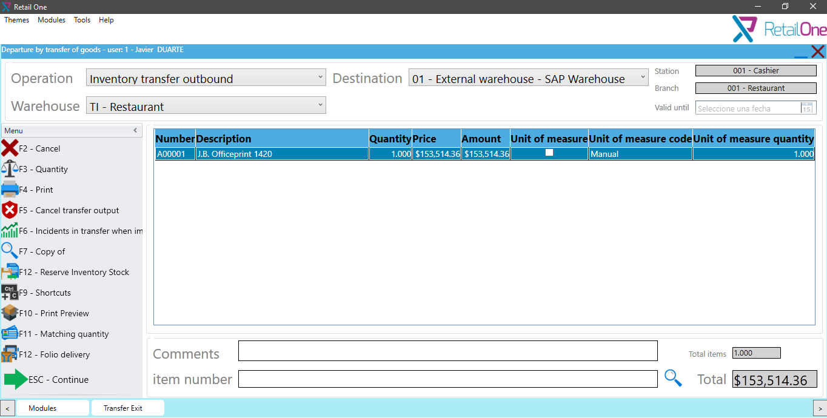

And is necessarily select responsible for this transportation.

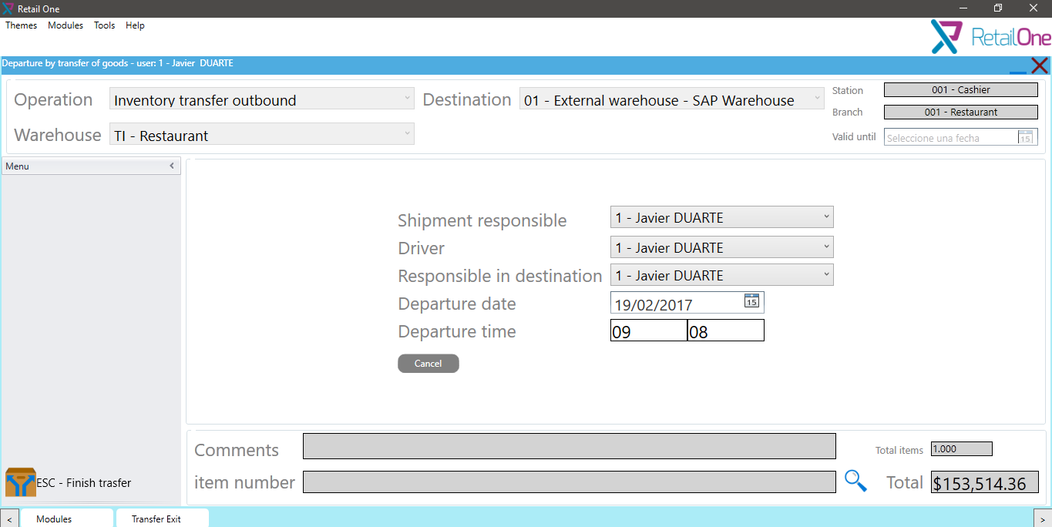

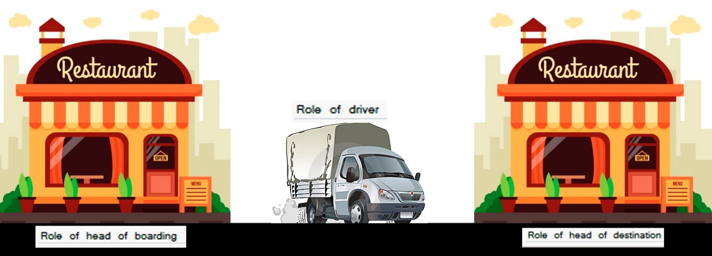

These roles are defined in Employee Master Data.

